FOR IMMEDIATE RELEASE
Contact: Rob Wray rwray@newonline.org
323.664.3198 Mobile 323.702.4709

NEW names 7 retail and consumer goods
executives to its board of directors

Lisa Walsh of Truco Enterprises advances to board chair
CHICAGO (January 17, 2018) -- The Network of Executive Women has named a new board chair and seven new members to its board of directors effective January 1.

Lisa Walsh, chief executive officer of Truco Enterprises, will be the women’s leadership organization’s new board chair, replacing Karen Stuckey, senior vice president, private brands general merchandise for Walmart.

Joining NEW’s board of directors are: Tracey Brown, senior vice president of operations and customer experience for Sam’s Club; Kelly Caruso, senior vice president, hardlines, at Target; Kendra Doyel, senior director, human resources for Ralph’s Grocery Company and Food 4 Less/Food Co. at Kroger; Michelle Freyre, president of U.S. Beauty at Johnson & Johnson Consumer Inc.; Abbe Luersman, chief human resources officer for Ahold Delhaize; Kim Underhill, global president for Kimberly-Clark Professional; and Ena Williams, senior vice president and head of international at 7-Eleven Inc.
“These women represent the best of NEW — successful business leaders who are passionate about gender equality at work,” NEW President and CEO Sarah Alter said. “We’re fortunate to have them guiding NEW as we strengthen our advocacy, broaden our reach, and roll out new programs that will help propel the careers of women at all levels and functions. We’re especially privileged to have Lisa as our new board chair. Her willingness to take on this demanding role speaks volumes about her commitment to gender equality.

[more]

Page 2 – NEW names new board members and chair

“Karen Stuckey has led NEW through a transformative period, as we have positioned ourselves to have a more powerful hand in shaping the future of the retail, consumer goods, technology and financial services sectors,” Alter added. ”As the board’s immediate past chair, we’ll continue to benefit from Karen’s influence and guidance — and we couldn’t be more grateful.”

Continuing to serve
Partnership Chair Monica Turner, vice president, customer business development for Procter & Gamble, will serve as board vice chair. NEW board directors at-large taking on new roles are Dagmar Boggs, president, 7-Eleven Global Team, for The Coca-Cola Company, who will serve as audit chair; Nicola Johnson, principal, consumer and industrial products practice, Deloitte Consulting, now technology chair; and Beth Marrion, managing director, retail, at Accenture, who will serve as regional chair.
Continuing their terms on the NEW Board are: Treasurer Erby Foster Jr., CEO of Foster Inclusion; Secretary Regenia Stein, principal at Ingenuity Consulting; Transformation Chair Vicki Felker, vice president and general manager, Golden Products Division at Nestlé Purina PetCare; and Compensation Chair Karen Mooney, chief human resources officer for Keystone Foods.
Returning to the NEW Board as directors at-large are: Dorria Ball, president and founder, Global Ballance Group, and Valerie Oswalt, president, U.S. sales, at Mondelēz International.
NEW Board members completing their terms are: Immediate Past Chair Elizabeth “Betsy” Hosick, general manager, procurement downstream, midstream and services for Chevron; Inclusion Chair Ken Charles, senior vice president, global talent at U.S. Bank; Regional Advisory Chair Marla Thompson, formerly senior vice president of Angie’s List; Marketing and Communications Chair Amy Hahn, senior vice president of marketing for Ahold USA; Audit Chair Suzan Kereere, head of global merchant client group of Visa Inc.; and Board Director At-Large Trish Adams, formerly executive vice president, merchandising product group at Target.
“These exceptional leaders have long been change agents who care deeply about fostering gender diversity,” Alter said. “We thank them for their service and know they will continue to be vocal, engaged advocates for workplace change.”

[more]

Page 3 – NEW names new board members and chair

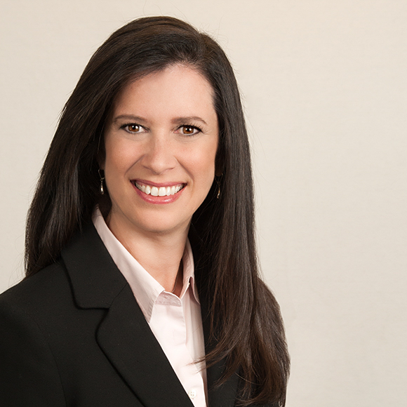
Lisa Walsh, NEW Board Chair

ABOUT NEW
Founded in 2001, the Network of Executive Women represents more than 10,000 members, 850 companies, 100 corporate sponsors and 21 regions in the U.S. and Canada advancing women and creating a better workplace for all. For more information about NEW and its learning programs, events, content and best practices, visit newonline.org. Connect with us on social media @NEWnational.

Network of Executive Women | 161 N. Clark Street | Chicago, IL 60601

