FOR IMMEDIATE RELEASE
Contact: Holly Goodhart hgoodhart@newonline.org
312.414.0229, ext. 22
Network of Executive Women and Deloitte Collaborate to Offer Research on Generation Z

The NEW report outlines the transformative impact Gen Z will have on the workplace
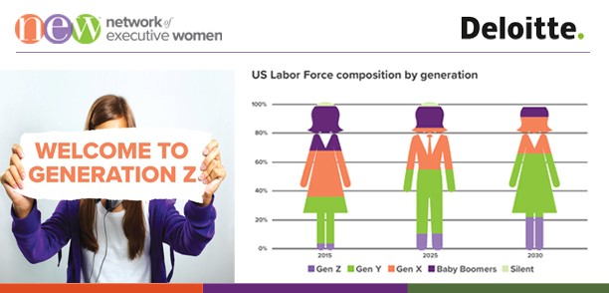

CHICAGO (September 19, 2019) –– Network of Executive Women has collaborated with Deloitte to produce actionable research on Gen Z. We surveyed an external group of 1,531 Gen Zers to produce proprietary research supporting the Network of Executive Women’s mission to advance women and strive for workplace transformation. Based on the research, the Network of Executive Women believes, this generation’s impact will be swift and profound, its effects rippling through retail consumption and technology, as well as in politics and culture.

Making up more than a quarter of the U.S. population, Gen Z influence nearly $44 billion in discretionary spending a year. By 2020, they will also be the most diverse generation in years. Gen Z is the most ethnically and racially diverse generation in history: One in four is Hispanic, 14% are African American and 6% are Asian, according to a 2018 study led by the Pew Research Center.

“Companies need to represent and promote a full spectrum of leadership that includes and embraces Gen Z’s worldviews,” said Karianne Gomez, lead author of the Gen Z Report, Vice President, Strategic Value at Network of Executive Women. “It’s time for companies to focus on advancing leaders who are committed to the unique needs of all workers, including those that this generation brings, and who can develop personalized experiences and entrepreneurial opportunities within the safety of stable employment for new employees.”

“In order for companies to attract and retain talent, they will need to think differently and align their priorities with those of the workforce of the future.” said Tiffany Mawhinney, Principal, Deloitte Consulting LLP
Last month, Tiffany Mawhinney, Principal Deloitte, and Danielle Robinson, Business Analyst Deloitte, presented the research findings at Network of Executive Women’s NEW Executive Forum – a gender equality conference event attended by 350 participants at the vice president and C-Suite Level.

Download the full “Gen Z Report” at newonline.org/genz.

ABOUT NEW
Founded in 2001, the Network of Executive Women is a nonprofit with a mission focused on gender equality plus diversity & inclusion initiatives. NEW represents nearly 13,000 members, 900 companies, 100 corporate partners and 22 regions in the U.S. and Canada advancing all women and building business. For more information about NEW and its learning programs, events, content and insights, visit newonline.org. Connect with us on social media @newnational.

ABOUT DELOITTE
Deloitte provides industry-leading audit, consulting, tax and advisory services to many of the world’s most admired brands, including nearly 90% of the Fortune 500® and more than 5,000 private and middle market companies. Our people work across the industry sectors that drive and shape today’s marketplace — delivering measurable and lasting results that help reinforce public trust in our capital markets, inspire clients to see challenges as opportunities to transform and thrive, and help lead the way toward a stronger economy and a healthy society. Deloitte is proud to be part of the largest global professional services network serving our clients in the markets that are most important to them. Our network of member firms in more than 150 countries and territories serves four out of five Fortune Global 500® companies. Learn how Deloitte’s approximately 286,000 people make an impact that matters at www.deloitte.com.

Deloitte refers to one or more of Deloitte Touche Tohmatsu Limited, a UK private company limited by guarantee (“DTTL”), its network of member firms, and their related entities. DTTL and each of its member firms are legally separate and independent entities. DTTL (also referred to as “Deloitte Global”) does not provide services to clients. In the United States, Deloitte refers to one or more of the US member firms of DTTL, their related entities that operate using the “Deloitte” name in the United States and their respective affiliates. Certain services may not be available to attest clients under the rules and regulations of public accounting. Please see www.deloitte.com/about to learn more about our global network of member firms.

Network of Executive Women | 161 N. Clark Street | Chicago, IL 60601

