FOR IMMEDIATE RELEASE
Contact: Rob Wray rwray@newonline.org
312.414.0229, ext. 22

NEW and Accenture team to boost women’s leadership in retail and consumer goods
CHICAGO (January 31, 2018) -- The Network of Executive Women is teaming with Accenture to help foster a more flexible, collaborative and inclusive workplace for women in the retail and consumer goods industry across North America.

A leading global professional services company with more than 170,000 women, Accenture recently elevated its 17-year relationship to become a NEW Foundation partner. As part of the partnership, the company is helping NEW conduct research to examine gender equality in the retail, consumer goods, technology and financial services workplace.

The research – based on NEW partner data, interviews, a survey of 1,300 NEW members and proprietary social media resources from Accenture – will be included in both an upcoming NEW position paper, which outlines the way forward for gender equality and diversity, and a special report on “pivot points,” focused on the career-changing choices women make.

NEW President and CEO Sarah Alter said, “Accenture has been with NEW since year one, and they have been a real partner in this workplace transformation journey, providing their support, guidance and insights, and helping us connect with other important players. It’s safe to say that NEW — and our mission — would not have come so far so fast without them.”

“Accenture and NEW share a commitment to helping more women advance to leadership positions — a critical element of an inclusive, equitable workplace,” added Julie Sweet, Accenture’s chief executive officer–North America. “The future workforce is an equal one, and by teaming with forward-thinking organizations like NEW, we will continue to see significant progress for women, in retail and beyond.”

[more]

Page 2 – NEW and Accenture expand partnership

“Too many Accenture executives to mention” have assisted NEW since its establishment in 2001, Alter said, but she singled out Accenture North America CEO Julie Sweet and Nellie Ferrero, Accenture’s Global Inclusion and Diversity Manager, who held an executive conversation on D&I at the NEW Leadership Summit 2017 in Washington, D.C.

Alter also saluted two Accenture managing directors for their NEW leadership — current NEW Board Member, Beth Marrion, and former NEW Board Member and Sponsor Development Chair, Mike Gorshe.

“Mike has been a constant champion of the Network throughout his career — he received the NEW Diversity Hall of Fame Award in 2014, one of only 10 individuals to be so honored,” Alter said.

“Beth recently stepped into the role of NEW Regional Advisory Chair and her guidance and insights on the industry have been invaluable.” Alter added that both “Mike and Beth have made numerous appearances at NEW events and have spoken for NEW countless times at industry meetings.”

She cited a panel on talent development held January 27 at FMI Midwinter, where Marrion appeared with Ahold Delhaize’s Subarna Malakar and Carole Christianson of the Western Association of Food Chains.

[more]

Page 3 – NEW and Accenture expand partnership

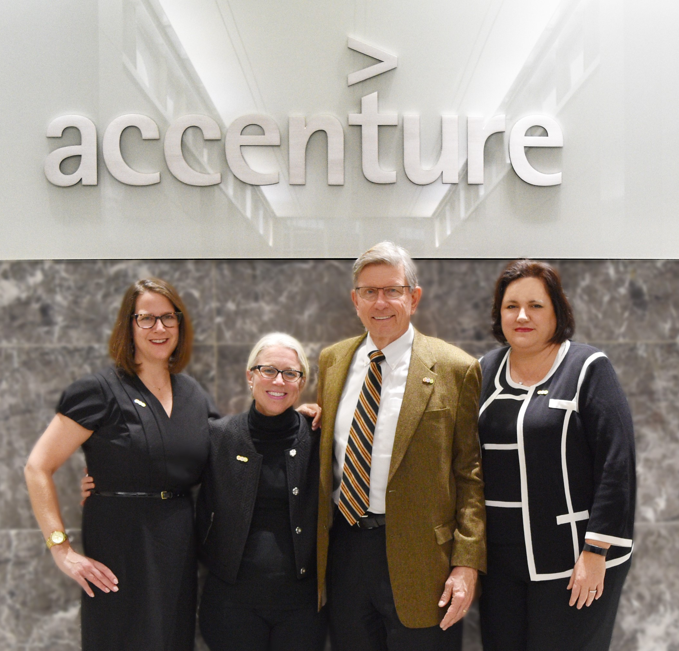
NEW and Accenture celebrate their alliance at their Chicago offices. Pictured from left: Beth Marrion, Accenture managing director; Sarah Alter, NEW CEO; Mike Gorshe, Accenture Managing Director; and Annette Cortese, Accenture Workplace Business Operations Lead.

ABOUT NEW
Founded in 2001, the Network of Executive Women represents more than 10,000 members, 850 companies, 100 corporate sponsors and 21 regions in the U.S. and Canada advancing women and creating a better workplace for all. For more information about NEW and its learning programs, events, content and best practices, visit newonline.org. Connect with us on social media @NEWnational.

Network of Executive Women | 161 N. Clark Street | Chicago, IL 60601

